**ACT**



Mata Praktikum : ORACLE INTERMEDIET

Kelas : 3IA20

Praktikum ke- : 8

Tanggal : 26 October 2022

Materi :

NPM : 50420900

Nama : Muhammad Reza Hidayat

Ketua Asisten :

Nama Asisten :

Paraf Asisten :

Jumlah Lembar :



**LABORATORIUM TEKNIK INFORMATIKA**

**UNIVERSITAS GUNADARMA**

**2022**

1. LISTING PROGRAM

declare

come emp.comm%type;

begin

select comm into come from emp

where ename = 'emp';

dbms_output.put_line('come : ' || come);

exception

when no_data_found then

dbms_output.put_line('data not found');

end;

/

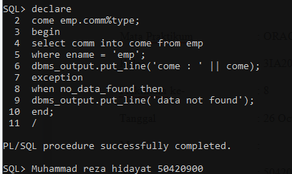

declare

name varchar2(100);

salary number;

begin

select ename, sal into name, salary from emp where empno = 7788;

if salary > 4500 then

raise_application_error(-20001, 'salary is too high');

end if;

dbms_output.put_line(name ||' '|| salary);

end;

/

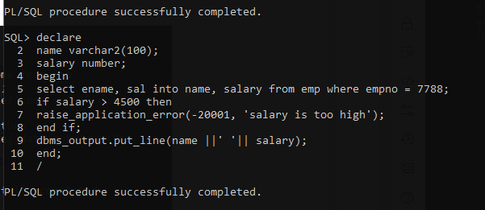

declare

name varchar2(100);

salary number;

begin

select ename,sal into name, salary from emp where empno = 7788;

if salary > 2000 then

raise_application_error(-20001, 'salary is too high');

end if;

dbms_output.put_line(name ||' '|| salary);

end;

/

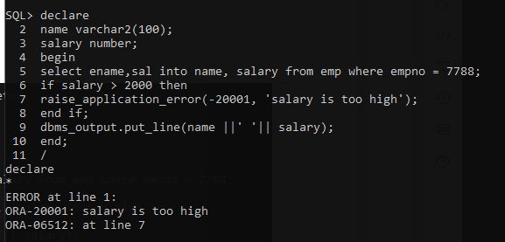

1. OUPUT PROGRAM